Healing YOUR Past with Reiki Workshop
Prerequisite: Reiki Level II
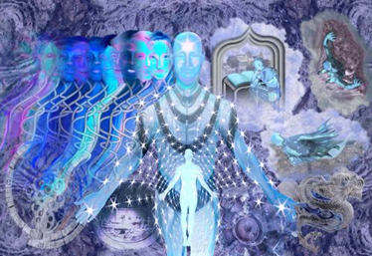
Are you interested in:
- Returning yourself or your client to wholeness?
- Establishing a solid foundation for wellness and vitality?
- Learning techniques which will help you to unlock the power within?
Do you want to:
- Learn techniques to overcome anxiety, pain or trauma?
- Live life to the fullest?
If you answered YES to one or more of these questions, then Healing YOUR Past with Reiki may be just the class you are looking for.
This class is recommended for Lightworkers who are Reiki level II or above. It will be a personal journey for each student as they work through various exercises and meditations designed to allow them to heal their past, by finding missing soul fragments of themselves. This technique is known as a Reiki Soul Retrieval.
A Reiki soul retrieval is a powerful method for practitioners because it helps to address depression, inability to move forward, feelings of not being present, as well as other health issues. The return of one’s soul can break patterns, open oneself to more choice, bring more enthusiasm into life, and give greater feelings of wholeness and a sense of well-being.
Students in this workshop will be trained on how to work with the issue of soul loss, explore causes of soul loss, learn how look for their own or their client’s soul and return it, as well as learn how to work with life after soul retrieval. Each student will receive their own soul retrieval, and learn techniques to help with the integration process after a soul retrieval.

MY PERSONAL EXPERIENCE
When I had my own Reiki Soul Retrieval back in 2004, I was already working as a healing practitioner, using Reiki and other healing modalities. The night after my soul retrieval session, I felt whole in a way I’d never experienced before. Within this conviction arose: “If I only get to do one thing for my students or clients, I want it to be soul retrieval, because this is a life changing experience.”
All these years later, that core conviction hasn’t changed. The work I do in my first session with a client has expanded a great deal in scope, but still holds that central commitment to return my client’s essence to them. To me, what soul retrieval provides is much like the difference between meeting a day with a good night’s sleep versus a night of insomnia. You’re still yourself in either case, but everything is easier if you’re well rested.
I am now offering to show these techniques to my students because I want my students to have the ability to use this proven process on themselves, their loved ones and their clients. I want my students to have a chance to be in the world with all their magic and power available to them in every situation, be it a joyful or challenging one.
All of the techniques demonstrated and experienced can then be used by the student for personal reasons now or in the future and can be easily incorporated into their Reiki practice.
The class includes time for discussion and feedback. Students receive a light breakfast, class handouts and a Certificate of Completion suitable for framing.
The class will be limited to six. The Workshop runs from 8:30 am until 4:00pm and carries 7 hours of NCBTMB CE hours
Prerequisites: Reiki Level II and Spiritual Protection or consent of Instructor.
The fee is $ 150.00
So please come and connect to your Spirit and your higher self. Discover what it is at the root of your problems and issues. Allow me to help you recognize the pieces of yourself that have been lost or given away.
In order to be truly happy, you must be whole and complete. When you regain the lost pieces of yourself, you regain your self-esteem, your courage and your self-confidence, which will speed the healing process of important issues that are holding you back, blocking your happiness.
I hope you are able to attend!

